Quality Analysis using Image Processing of Real Time Data in Industry 4.0

### Iteration-II Deliverables

## 

## Supervisor

Dr. Faraz Junejo

## Submitted by

Zohair Lokhandwala

{1612258}

Sibte Abbas

{1612135}

**Faculty of Computing and Engineering Sciences**

Shaheed Zulfiqar Ali Bhutto Institute of Science and Technology, Karachi.

[1st November 2019]

Table of Contents

Iteration Plan 2

ERD 3

Domain Model 3

System Sequence Diagram 4

Use Cases 5

Test Cases 7

Gantt Chart 9

Iteration Plan

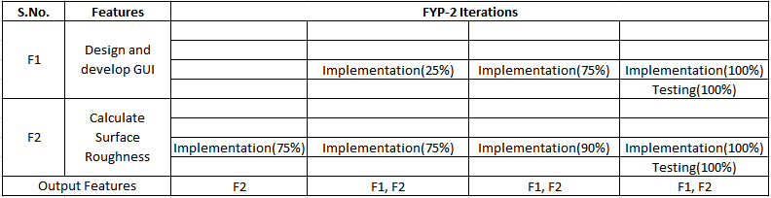

Erd

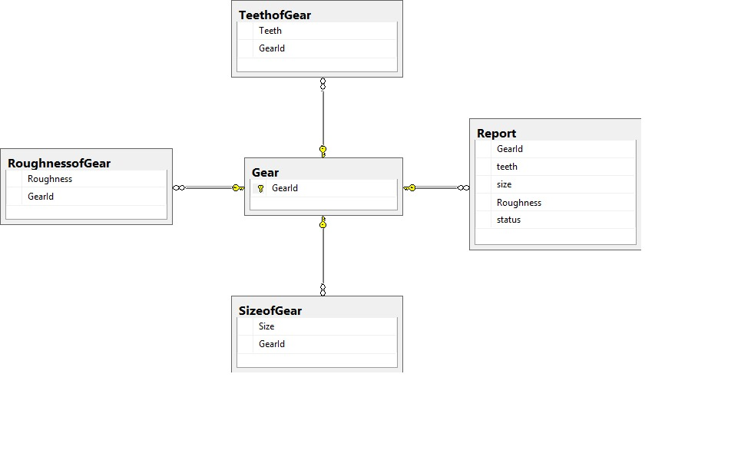

Domain Model

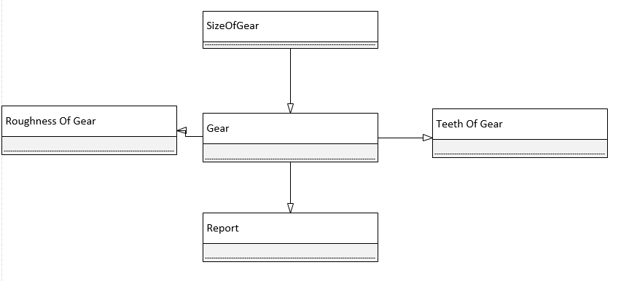

System Sequence Diagram

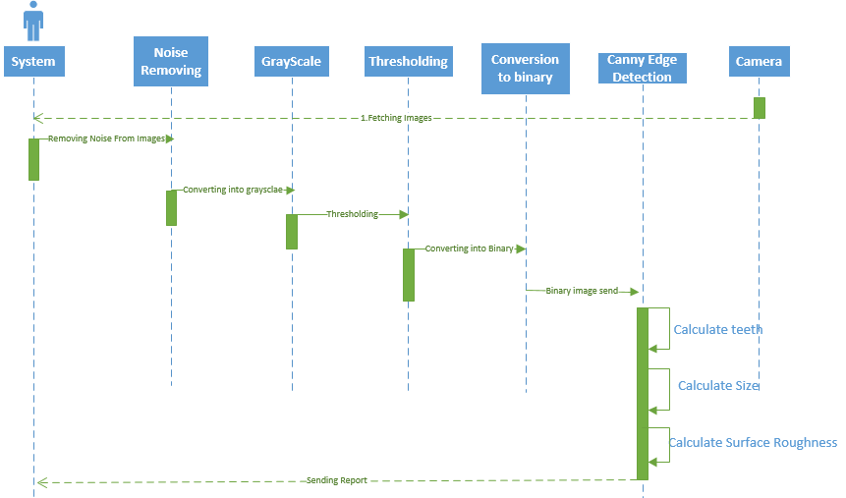

Use case diagram

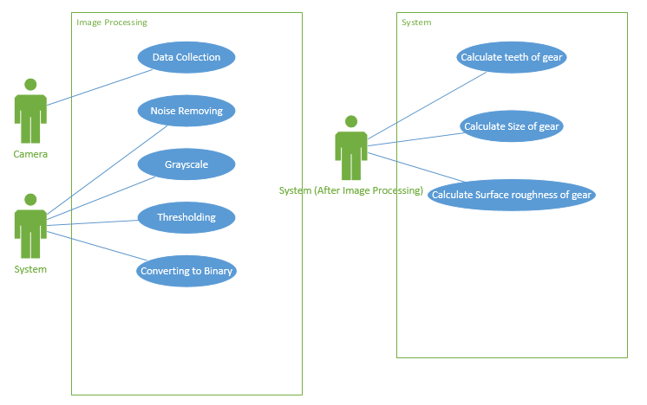

Use Cases

|  |  |
| --- | --- |
| Use-Case # | Uc-001 |
| Description | Camera will capture the images |
| Pre-Condition | Camera should be powered on |
| Use-Case | |  |  | | --- | --- | | Camera will capture the images | Image captured into the camera | |
| Post-Condition | Data will be uploaded to the servers. |

|  |  |
| --- | --- |
| Use-Case # | Uc-002 |
| Description | Data will be uploaded onto the server |
| Pre-Condition | Image should be captured and the camera is connected to the server. |
| Use-Case | |  |  | | --- | --- | | Data uploaded on server | Images saved on server | |
| Post-Condition | System will fetch data from the server |

|  |  |
| --- | --- |
| Use-Case # | Uc-003 |
| Description | System will fetch image |
| Pre-Condition | System should be connected to cloud |
| Use-Case | |  |  | | --- | --- | | Images ready to be processed | Images will be opened into the system | |
| Post-Condition | Image will be processed |

|  |  |
| --- | --- |
| Use-Case # | Uc-004 |
| Description | Noise removal of the images |
| Pre-Condition | Image should in process |
| Use-Case | |  |  | | --- | --- | | Noise Removal | It will remove the noise from the image | |
| Post-Condition | Output image with noise removed |

|  |  |
| --- | --- |
| Use-Case # | Uc-005 |
| Description | Convert image into greyscale |
| Pre-Condition | Image should be in process |
| Use-Case | |  |  | | --- | --- | | Conversion to greyscale | The image will be converted into greyscale. | |
| Post-Condition | Output image into greyscale |

|  |  |
| --- | --- |
| Use-Case # | Uc-006 |
| Description | Setting threshold |
| Pre-Condition | Image should be converted into greyscale |
| Use-Case | Set Threshold value | Threshold value will be set |
| Post-Condition | Threshold value adjusted |

|  |  |
| --- | --- |
| Use-Case # | Uc-007 |
| Description | Conversion to Binary |
| Pre-Condition | Image should be in grayscale format |
| Use-Case | Converting image to Binary | Image will be converted into binary form |
| Post-Condition | Image converted into binary |

|  |  |
| --- | --- |
| Use-Case # | Uc-008 |
| Description | Calculating Teeth’s of gear |
| Pre-Condition | Image should be in binary format |
| Use-Case | |  |  | | --- | --- | | Calculating number of teeth of gear using edge detection algorithms | Report will be generated | |
| Post-Condition | Number of teeth |

|  |  |
| --- | --- |
| Use-Case # | Uc-009 |
| Description | Calculating size of gear |
| Pre-Condition | Image should be in binary format |
| Use-Case | Calculating size of gear | Report will be generated |
| Post-Condition | Diameter of the gear in float |

|  |  |
| --- | --- |
| Use-Case # | Uc-0010 |
| Description | Calculate Surface roughness |
| Pre-Condition | Image should in binary form |
| Use-Case | |  |  | | --- | --- | | Calculating surface roughness of gear | Report will be generated | |
| Post-Condition |  |

# Test Cases:

**Test Case # 1**

|  |  |  |  |  |  |
| --- | --- | --- | --- | --- | --- |
| **Test Case ID** | **Test Case Name** | **Test Case Summary** | **Test Case Steps** | **Expected Result** | **Actual Result** |
| **TestCase_1** | Fetch Images | Fetching images from camera, which is connect to Server. | Connected to Server | Fetch Image properly. | Passed |

**Test Case # 2**

|  |  |  |  |  |  |
| --- | --- | --- | --- | --- | --- |
| **Test Case ID** | **Test Case Name** | **Test Case Summary** | **Test Case Steps** | **Expected Result** | **Actual Result** |
| **TestCase_2** | Remove Noise | Remove Noise From picture to clear the image which increase processing | Apply bilateral Filter and median blur filter | Remove all unwanted Pixel | Passed |

**Test Case # 3**

|  |  |  |  |  |  |
| --- | --- | --- | --- | --- | --- |
| **Test Case ID** | **Test Case Name** | **Test Case Summary** | **Test Case Steps** | **Expected Result** | **Actual Result** |
| **TestCase_3** | Count teeth | Calculate Teeth of gear using Canny edge detection and contours. | Apply Canny algorithm then using contours detect outer edges and draw contour on them. | Count Exact teeth in gear | Passed |

Gantt Chart

